1. Calling the endpoint /message before refreshing the property config – accessing the default client message

URL sent: (GET) http://localhost:5454/message

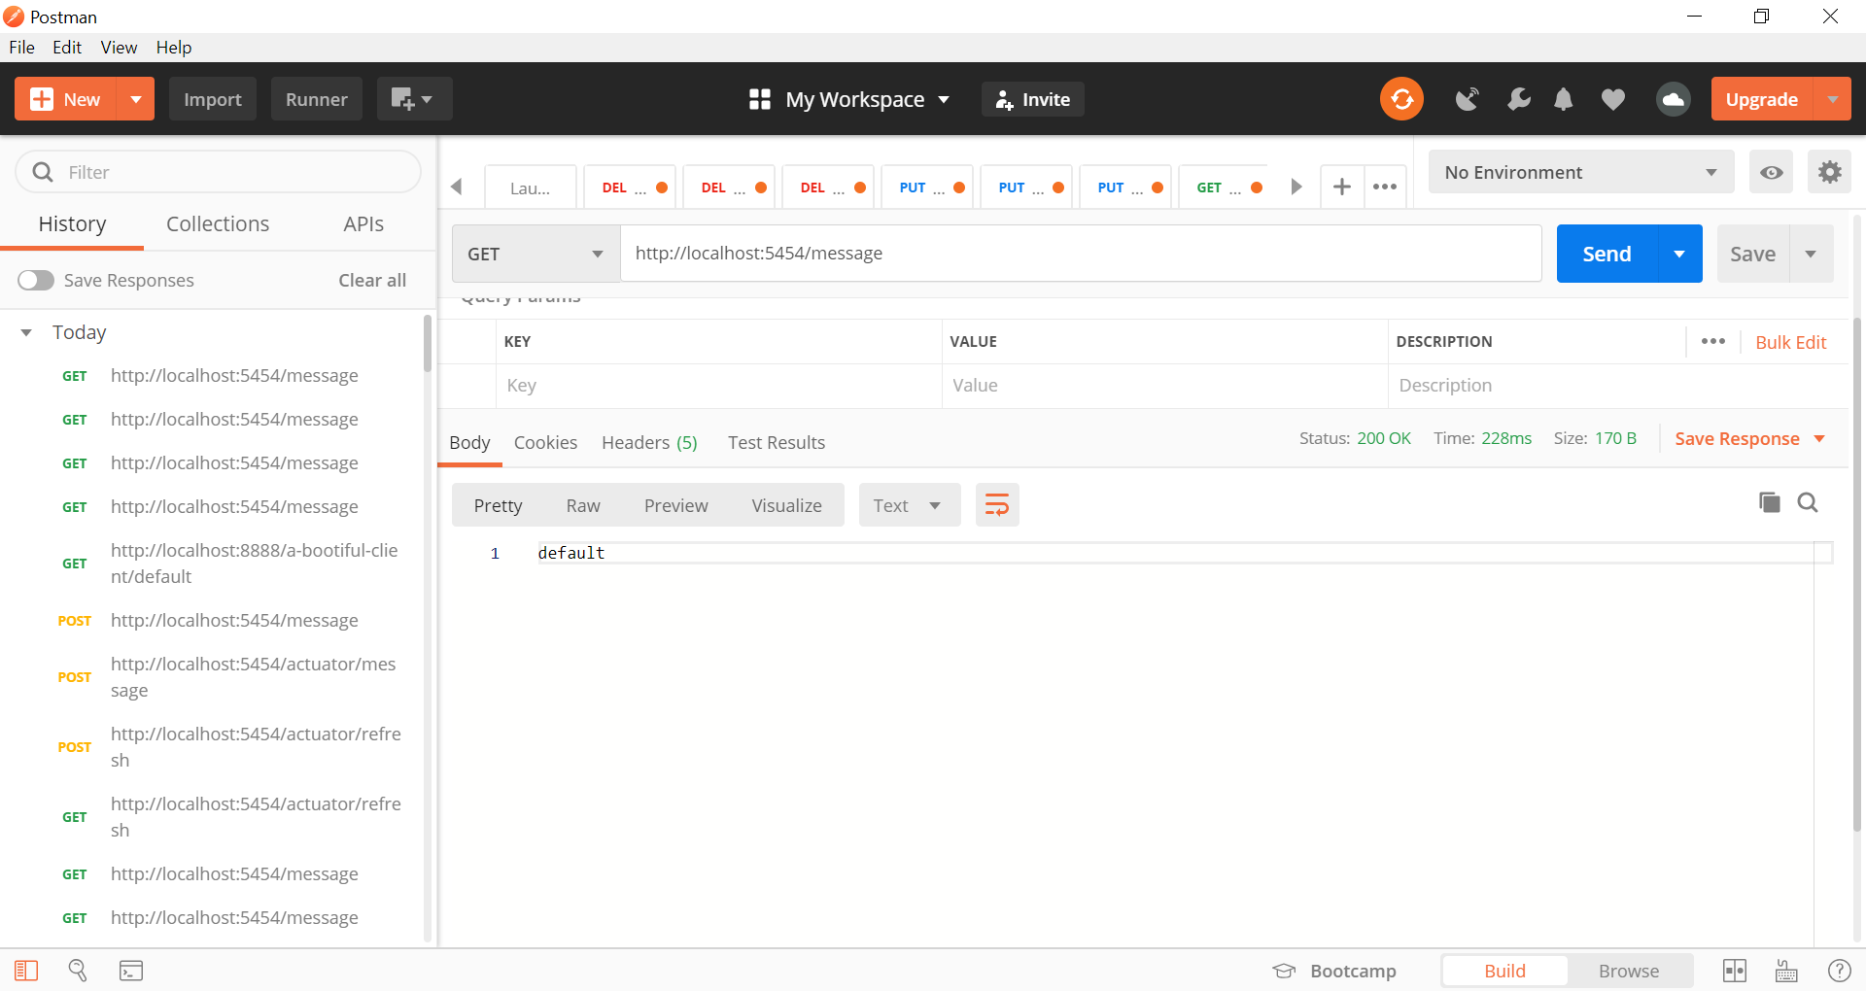

1. Doing POST method of actuator to refresh the property

URL sent: (POST) http://localhost:5454/actuator/refresh

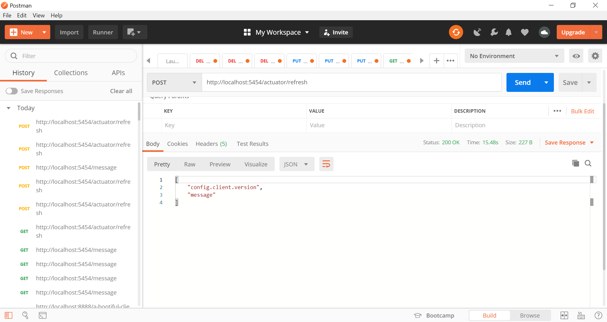

1. Calling the endpoint /message before refreshing the property config – accessing a config file through a server

URL sent: (GET) http://localhost:5454/message

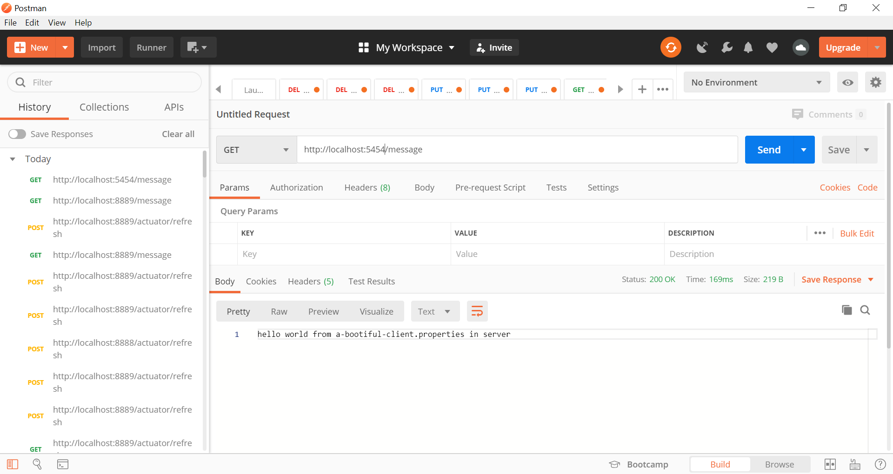

1. Checking to see if a-bootiful-client.properties is found

URL sent: (GET) http://localhost:8888/a-bootiful-client/default

